Young People in the Lead Organisational Self-Assessment Tool
This tool has been designed through consultation with care and custody leavers and the practitioners who support them. It comes out of an eight-year, National Community Lottery Fund project, Future 4 Me, created and delivered by 1625 Independent People and is the culmination of project learning.
It is designed to support you, as an organisation working with care and custody leavers, to:
- reflect upon, assess and evidence your strengths
- reflect upon, assess and evidence potential areas of improvement
- identify best practice and barriers to effective working
- identify next steps and begin an action plan for improvement
We hope that by working through this Self-Assessment Tool, and identifying the strengths of your organisation, you will come away with increased confidence in the role your service can play in supporting vulnerable young people, as well as learning you could share with partners. We hope that by consolidating some of your thinking around areas of your service, you come away with enthusiasm and ideas for how to make positive changes.
The tool focuses on four areas which have been identified as having a key impact on services for care and custody leavers:
- Listening
- Multi Agency Relationships
- Service Delivery
- Staff Wellbeing
For some organisations, certain questions may not feel relevant, and we have included the option to indicate ‘not applicable’. The hope is however, that the majority of questions will be. After completion of the Self-Assessment Tool we suggest you spend between 5-30 minutes identifying helpful actions for your organisation. This might be as simple, and quick as sharing your findings with your colleagues or putting an item on the agenda for the next management meeting. Alternatively, it could take the form of creating a SMART plan around an area of practice or a service.

How to use this Self-Assessment Tool
The tool can be used in a variety of ways, depending on the time available to you and the extent to which you feel able to reflect on the statements posed.
Option A – Very light touch, 15 minutes. Answer Yes or No against the core statements in bold.

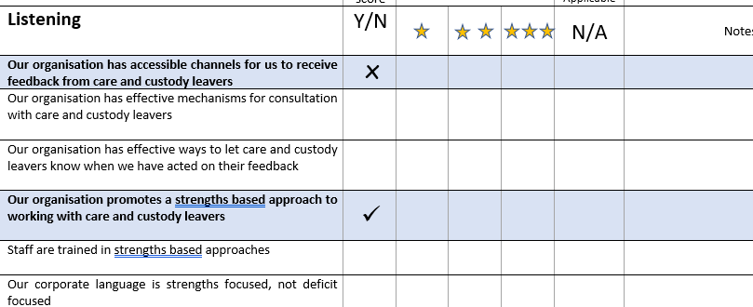

Core statements appear in bold text with a coloured background

Option B – Light touch, 30 minutes. Score yourself 1, 2 or 3 stars against all statements, adding comments if you wish.
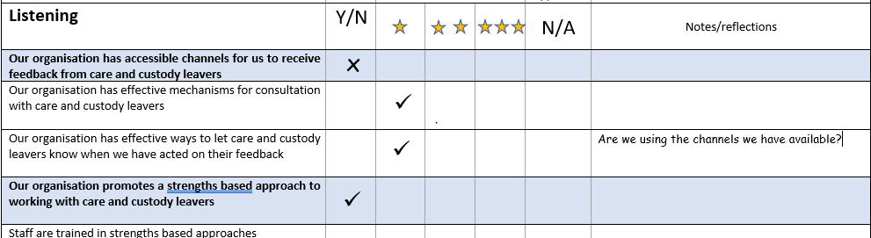

You might want to think about defining your 1,2 and 3 star ratings before you begin, to help you score consistently. For example:
1 star could mean ‘Starting to Implement’
2 stars could mean ‘Consistently Good Practice’
3 stars could mean ‘Leader in our Sector’
This will also help you if more than one person is going to complete the self-assessment.
Its

Option C – In depth, 60-90 minutes. Complete as many sections as are relevant, and use the notes section to evidence good practice/highlight actions

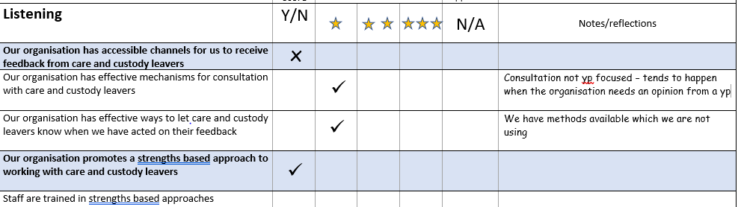

Try to make notes which will help you decide what action to take next, or which support the score you have awarded yourself. For example, here it might have been helpful to add details of the methods which are not being used, so they could be reviewed. Being clear now will also save you time rewriting or explaining if you decide to share your findings with others.

Action Planning
Once you have completed your self assessment, it is important that you convert your findings into actions. You might have your own action planning resources you can use for this – if not we have suggested two simple questions to help you start the process.

Next steps/Action Plan
What have you identified that is working well in your organisation? (Recognise and celebrate success!)

Areas identified that needs action or improvement | Who | By when | Notes

Remember to make your actions SMART – Specific, Measurable, Achievable, Realistic and Time Bound
Don’t be tempted to skip the step of recognising and celebrating what you are already doing well – sharing these successes can be an important way of communicating your organisational values and getting everyone on board with your future plans!
Finally – keep in mind that assessments of any kind can cause people stress. We have intentionally designed this tool to support a strengths based approach to developing good practice – there is no ‘pass’ or ‘fail’. Keeping a focus on strengths and potential will help everyone to see this as a positive learning process, and your organisation can only benefit from that.

Young People in the Lead
Organisational Self Assessment Questions

Before you begin, refer to the instructions on pages 2 - 5 ‘How to use this Self-Assessment Tool’

Section 1 | Quick score | Star rating 1-3 |  |  | Not Applicable | Notes/reflections
Listening | Y/N |  |  |  | N/A
- Our organisation has accessible channels for us to receive feedback from care and custody leavers
- Our organisation has effective mechanisms for consultation with care and custody leavers

- Our organisation has effective ways to let care and custody leavers know when we have acted on their feedback
- Our organisation promotes a strengths-based approach to working with care and custody leavers
- Staff are trained in strengths-based approaches

- Our organisational language is strengths focused,

- Deficit based approaches in multi-agency working are challenged appropriately

- Care & custody leavers are consulted when we produce external communications material which is relevant to them
- Care & custody leavers have input into our organisational priorities

- Care & custody leavers are involved in writing or reviewing our policies and procedures

- Care & custody leavers have structured opportunities to communicate with all levels of the organisation
- Care & custody leavers have opportunities to shape the services we offer for them

- Our organisation advocates for care and custody leavers in the wider world

- Our organisation has influence over local policy regarding care and custody leavers

- Our organisation has influence over national policy regarding care and custody leavers

- Our policies and procedures reflect national legislation and good practice guidance as this applies to care and custody leavers
- Our organisation adopts a proactive approach to the recruitment of care and custody leavers

- We have recruitment policies which promote equality of opportunity and value lived experience

- We have volunteering policies which promote equality of opportunity and value lived experience
Section 2 | Quick score | Star rating 1-3 |  |  | Not Applicable | Notes/reflections
Multi-Agency Relationships | Y/N |  |  |  | N/A
- Our organisation has safe and effective practice around multi-agency information sharing

- Staff have access to appropriate mechanisms to safely share information with partner organisations
- Staff have access to spaces which allow for collaborative working

- Staff are trained regularly in confidentiality and data protection good practice

- Our organisation is regularly and effectively represented at relevant local multi-agency forums

- Our organisation has practices which protect care and custody leavers during transitions*
- Staff are trained in managing transitions

- Our organisation has policies and procedures for ensuring effective handover of information between staff/shifts
- Our organisation has policies and procedures to effectively cover unexpected staff absences

- Our organisation offers an out of hours support which is effectively staffed

*Transitions: into or out of services, into or out of custody, changes of worker due to illness, absence or staff leaving

Section 3 | Quick score | Star rating 1-3 |  |  | Not Applicable | Notes/reflections
Service Delivery | Y/N |  |  |  | N/A
- Our organisation uses a trauma informed approach to delivering our services

- Staff are trained in trauma informed approaches

- Our staff have the flexibility to structure service delivery in a way which takes each individual’s needs into account
- Our services can be accessed in a variety of ways to allow for different communication preferences

- We have systems in place to capture evidence about how effective our approaches are with care and custody leavers
- When carrying out assessments, we collect only the information we need and will use, and we store it securely and share it safely
- Our organisation has physical spaces which are appropriate to the work we do, and the number of staff and service users accessing them
- Our organisation has a designated facilities lead or team responsible for maintaining our physical spaces in good order
- Our organisation has spaces which are safe and accessible for care and custody leavers to use

Section 4 | Quick score | Star rating 1-3 |  |  | Not Applicable | Notes/reflections
Staff Wellbeing | Y/N |  |  |  | N/A
- Our organisation has policies and procedures which actively promote staff wellbeing

- All staff know how to access support with their wellbeing at work

- Staff wellbeing is a regular management agenda item

- All staff have regular 1-2-1’s, supervision and/or mentoring

- Our organisation provides ongoing opportunities for staff to develop and improve their practice

- Our organisation offers regular, relevant training opportunities

- Our organisation offers time and space for staff to reflect on their work

- Our organisation offers opportunities for staff to shape service delivery and influence our direction

- Our organisation offers regular opportunities for staff to interact with colleagues outside their own team
- Our organisation has a staff representation body

- Our organisation has mechanisms for receiving feedback from staff at all levels

- Staff are involved in designing new services

Next steps/Action Plan
What have you identified that is working well in your organisation? (Recognise and celebrate success!)

Areas identified that needs action or improvement | Who | By when | Notes

Further Resources for Organisations working with Care & Custody Leavers
My Covenant - Government funded website which sets out the terms of the Care Leaver Covenant, and acts as a hub for examples of good practice in supporting care leavers to become more independent. https://mycovenant.org.uk/
Beyond Youth Custody –although the Beyond Youth Custody programme is now closed, the site still has useful resources, research and links produced during this 6 year lottery funded project http://www.beyondyouthcustody.net/
Clinks – Supporting voluntary sector organisations working with the criminal justice system – information, briefings, training and events https://www.clinks.org/
The Howard League – Campaigning for less crime, safer communities and fewer people in prison – Amongst their other services, The Howard League offer a free confidential legal helpline for young people in prison https://howardleague.org/

