Young People in the Lead Self-Assessment Tool for Individual Workers/Teams
This tool has been designed through consultation with care and custody leavers and the practitioners who support them. It comes out of an eight-year, National Community Lottery Fund project, Future 4 Me, crated and delivered by 1625 Independent People and is the culmination of project learning. It is designed to support you, as a practitioner working with care and custody leavers, to:
- reflect upon, assess and evidence your strengths
- reflect upon, assess and evidence potential areas of improvement
- identify best practice and barriers to effective working
- identify next steps and begin an action plan for improvement
We hope that by working through this Self-Assessment Tool, and identifying your individual strengths, you will come away with an increased confidence in your abilities as a practitioner, as well as learning you can share with colleagues. We hope that by consolidating some of your thinking around areas of your practice, you come away with enthusiasm and ideas for how to make positive changes.
The tool focuses on four areas which have been identified as having a key impact on support for care and custody leavers:
- Voice – understanding and advocacy
- Relationships – working with others
- Support – being alongside
- Looking after yourself and others
For some practitioners, certain questions may not feel relevant, and we have included the option to indicate ‘not applicable’. The hope is however, that the majority of questions will be. After completion of the Self-Assessment Tool we suggest you spend between 5-30 minutes identifying helpful actions. This might be as simple, and quick as sharing your findings with your colleagues or putting an item on the agenda for your next team meeting. Alternatively, it could take the form of creating a SMART plan around an area of practice.

How to use this Self-Assessment Tool;
The tool can be used in a variety of ways, depending on the time available to you and the extent to which you feel able to reflect on the statements posed.

Option A – Very light touch, 15 minutes. Answer Yes or No against the core statements in bold.
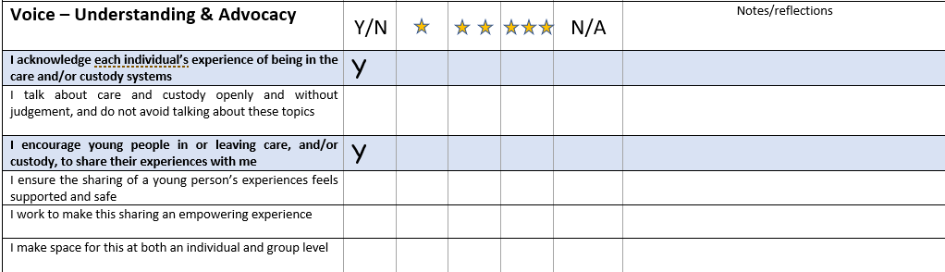
Example:

Option B – Light touch, 30 minutes. Rate yourself 1, 2, or 3 stars against both the headings and the detailed questions.
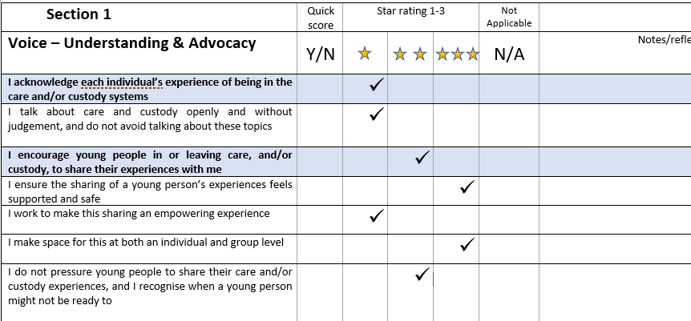
Example:

Note: If you are doing the assessment as a team exercise, you may find it helpful to discuss how you will define the one, two and three star ratings before you begin – this will be different in different settings, but one option could be :
1 star = doing this sometimes
2 stars = consistently doing this
3 stars = modelling best practice in this area

Option C – In depth, 60-90 minutes. Complete as many sections as are relevant and add notes to indicate how you are meeting each criterion. Example:
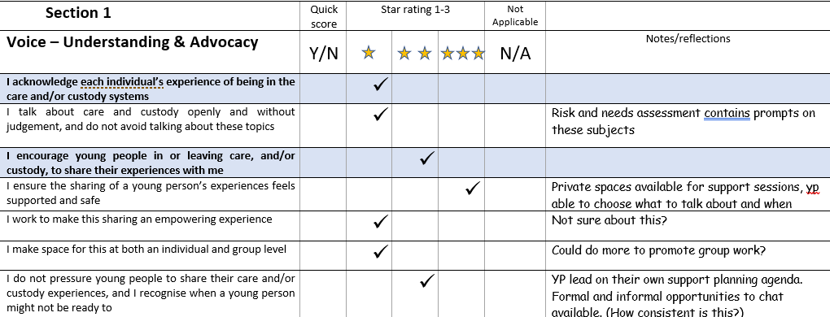

Identifying Actions
Each section ends with a prompt to identify action points for improvement:
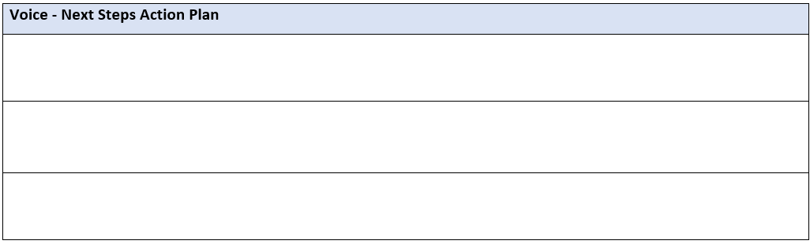
Share self-assessment with line manager at next supervision

Add discussion about support for care leavers to our next team meeting agenda
Where possible we suggest that whole teams use this tool at an individual level, before regrouping to identify shared opinions and next steps at a team level.
This tool can also be used in conjunction with our Young People in the Lead Organisational Self-Assessment Tool, designed to be completed by leaders.

Young People in the Lead
Individual/Team Self-Assessment Questions

Before you begin, refer to the instructions on pages 2-5 ‘How to use this Self-Assessment Tool’

Section 1 | Quick score | Star rating 1-3 |  |  | Not Applicable | Notes/reflections
Voice – Understanding & Advocacy | Y/N |  |  |  | N/A
- I acknowledge each individual’s experience of being in the care and/or custody systems

- I talk about care and custody openly, without judgement, and do not avoid talking about these topics
- I encourage young people in or leaving care, and/or custody, to share their experiences with me
- I ensure the sharing of a young person’s experiences feels supported and safe

- I work to make this sharing an empowering experience

- I make space for this at both an individual and group level

- I do not pressure young people to share their care and/or custody experiences, and I recognise when a young person might not be ready to
- I believe that young people are more than their care and/or custody history

- I support young people to know themselves, and to recognise their unique qualities and strengths

- I work to empower young people to see themselves as more than their care or custody history
- I talk about care and/or custody leavers in a positive way

- I avoid using jargon, acronyms or overly complex language when I talk to young people

- I use these, but check understanding, when they are relevant to discussions with young people

- I empower young people to know and own the words that describe their experiences

- I consider young people’s developmental stage and level of understanding when I talk to them

- I act as an advocate for the young people I work with as required

- I support young people to know their rights and responsibilities

- I give young people choices around the advocacy I provide

- I recognise when young people may need me to speak on their behalf, and when it is more appropriate and empowering to encourage them to speak for themselves
- I work in a care/custody leaver led way

- I ask young people what is important to them

- I am aware of ways of working I can use to encourage this

- I help young people work out what is important to them now, and in the future, and my support plans reflect this
- My workload allows time and space to do the above.

Voice - Next Steps Action Plan | Who | By when | Notes

Section 2 | Quick score | Star rating 1-3 |  |  | Not Applicable | Notes/reflections
Relationships – Working with others | Y/N |  |  |  | N/A
- My working relationships with others are positive (e.g. effective communication, supportive interactions, information sharing etc)
- My working relationships with colleagues within my organisation are positive

- My working relationships with colleagues outside of my organisation are positive

- My working relationships with young people are positive

- I know who else can provide support to the young people I work with

- I make appropriate referrals into other services

- I am aware of specific support entitlements for care and custody leavers, and how to access these

- I acknowledge that young people need different kinds of working relationships

- I am aware of the strengths of my working relationship with young people

- I am aware of the limitations of my working relationship with young people

- I understand that my own values, history, opinions and beliefs can affect my working relationships with young people
- I seek out other positive relationships for the young people I work with, where appropriate, spotting where others may be able to offer things that I cannot
- The space(s) I work within is helpful to working well with others (e.g. hotdesking, knowing who people are)
- My workspace/environment enables me to work well with colleagues within my organisation

- My workspace/environment enables me to work well with colleagues beyond my organisation

- My workspace/environment enables me to work well with young people

- My workspace/environment enables me to work well with young people and the people they care about/care about them (e.g. family members with whom they have a positive relationship)

- I acknowledge the impact of project constraints and targets

- I feel that worker-specific, and project targets, enable this work to be young person led

- When project constraints threaten effective working, I am able to challenge or influence

- I feel able and empowered to share information appropriately

- The policies, processes and practices within my organisation allow for me to share information as appropriate
- The records I, and others, keep enable and empower positive work with young people

- I can manage risks through the sharing of appropriate information

- I feel able and empowered to say no if I need to

- I feel able to say no to a referral if I feel it is not in the best interests of the young person

- I feel able to say no to a referral if I feel I don’t have enough information to manage risk appropriately
- I feel able to say no to young people when I feel it is appropriate to do so

- When saying no I can maintain positive working relationships with the referring person / organisation
- My workload allows time and space to do the above.

Relationships - Next Steps Action Plan | Who | By when | Notes

Section 3 | Quick score | Star rating 1-3 |  |  | Not Applicable | Notes/reflections
Support – Being alongside | Y/N |  |  |  | N/A
- I am able to meet some of the needs of the care and custody leavers I work with

- I check in with young people and ask if their basic needs are being met, (e.g. have they eaten, do they have shelter, are they warm enough etc.)
- I am able to meet some of the basic needs of the young people I work with, if these needs haven’t been met today (e.g provide food, postpone a meeting if they are tired)
- I can meet a young person where they ‘are at’

- Within reason, I am able to meet young people at places that suit them and their needs

- I am able to assess young people and adjust my ways of working, expectations and demands accordingly (e.g. developmental level, past trauma, mood on the day etc)
- I use a range of appropriate assessment approaches & techniques, tailoring these to young people as individuals
- I know what to do if a young person changes address, or becomes homeless, as well as what this means for our work together
- I know what to do if a young person I am working with enters or re-enters custody, as well as what this means for our work together
- I support and empower young people to be more independent through the work I do

- The work I do improves young peoples’ access to employment, education and training

- The work I do helps young people to have more stability in their lives, and feel safe and secure

- The work I do improves young peoples’ access to health and emotional support

- The work I do supports young people to be more financially independent

- My workload allows time and space to do the above.

Support – Being alongside - Next Steps Action Plan | Who | By when | Notes

Section 4 | Quick score | Star rating 1-3 |  |  | Not Applicable | Notes/reflections
Looking after Yourself and others | Y/N |  |  |  | N/A
- I enjoy my work

- I feel safe at work

- I feel supported at work

- I know how much annual leave I am entitled to, and how to request it

- I am able to take my annual leave, in a way that suits me

- My organisation has a flexi-time policy

- I understand, and agree with, my role and responsibilities

- My role has clear aims and objectives

- My organisation offers time and space to process and reflect upon the work I do

- I know how to effectively safeguard the young people I work with (including how to follow relevant policies and procedures around this)
- I know how to raise a safeguarding concern and who to direct it to

- I help create a safe space for young people, so they feel able to make disclosures

- I have positive conversations with young people around their wellbeing, and how they can keep themselves safe and well
- Where appropriate I encourage young people to take ownership of their own wellbeing, and recognise risks they or others pose to them
- My workload allows time and space to do the above.

Looking after Yourself and Others - Next Steps Action Plan | Who | By When | Notes

